Spring Web MVC使用XML設定檔範例
預覽應用程式執行流程
Spring MVC DispatcherServlet 讀取 xml 組態檔案的原則：
- {servlet-name} ==> /WEB-INF/{servlet-name}-servlet.xml
- 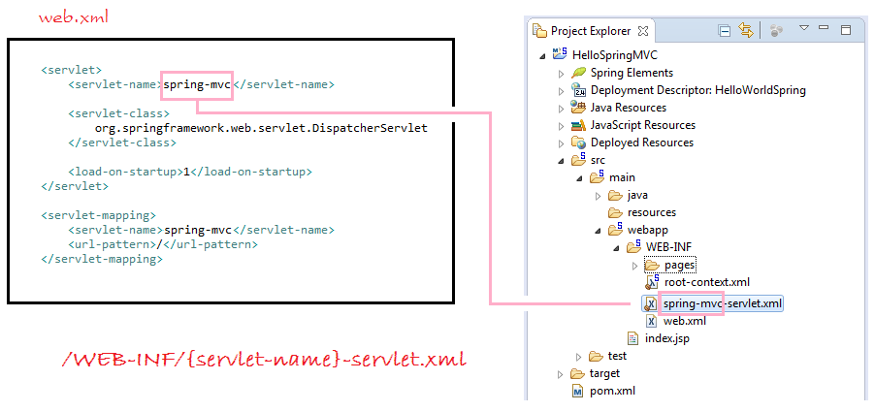
如果你不想用 spring-mvc-servlet.xml 的使用原則，可以重新設定組態 DispatcherServlet 在 web.xml 檔案中：
<servlet>
<servlet-name>my-dispatcher-name</servlet-name> <servlet-class>org.springframework.web.servlet.DispatcherServlet</servlet-class>
<init-param>
<!-- override default name {servlet-name}-servlet.xml -->
<param-name>contextConfigLocation</param-name>
<param-value>/WEB-INF/myspringconfig.xml</param-value>
</init-param>
<load-on-startup>1</load-on-startup>
</servlet>

現在我們開始！
第1步：建立所需的目錄結構專案
使用Eclipse建立一個Maven web專案 並一步一步的建立Maven專案。
以下將是最後的專案結構。
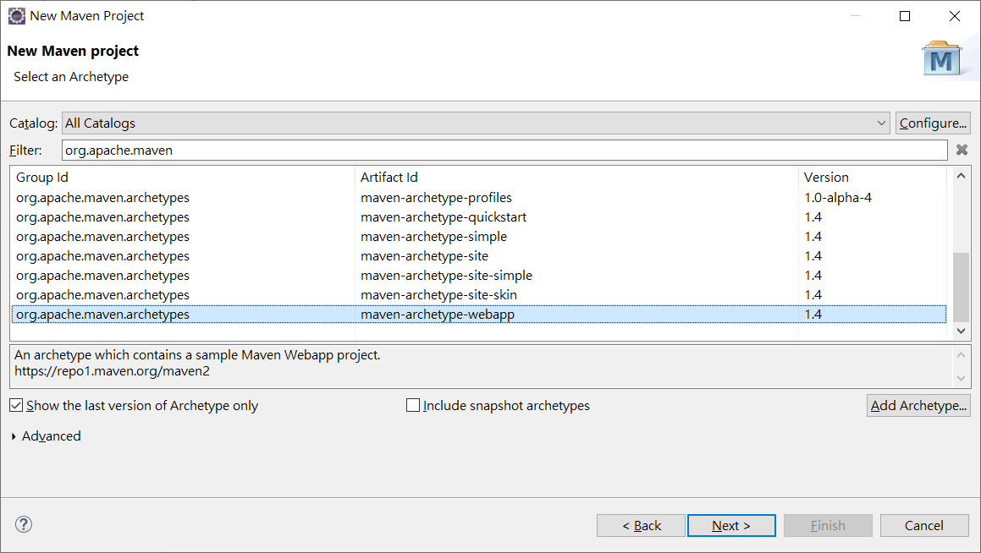
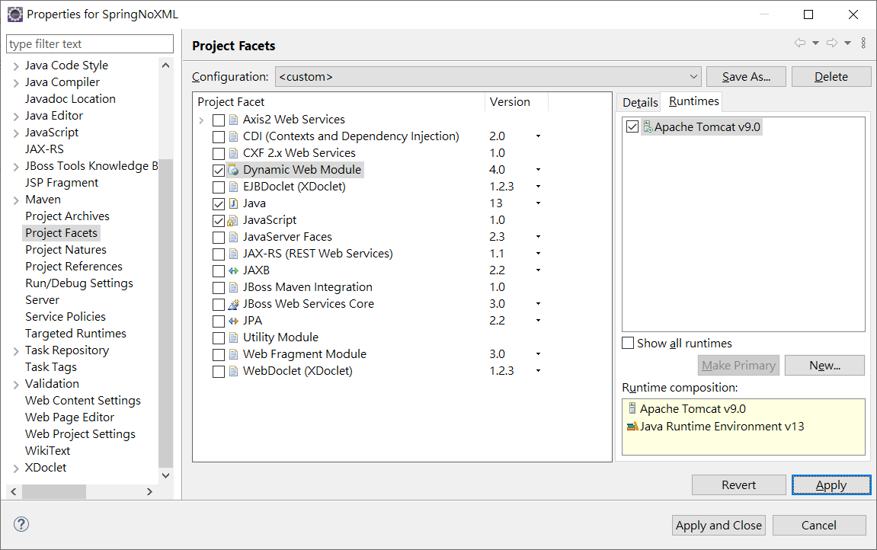

現在，讓我們來新增/更新上面討論專案結構中每一個細節提到的內容。
第2步：使用Spring和Servlet依賴更新pom.xml
我們要討論以 Spring為基礎的組態取決於Servlet 4.0 的API， 因此我們需要包含的依賴在 pom.xml 中。
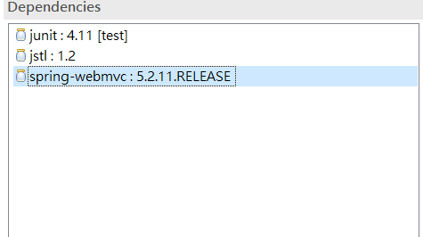
pom.xml
<?xml version="1.0" encoding="UTF-8"?>

<project xmlns="http://maven.apache.org/POM/4.0.0" xmlns:xsi="http://www.w3.org/2001/XMLSchema-instance"
xsi:schemaLocation="http://maven.apache.org/POM/4.0.0 http://maven.apache.org/xsd/maven-4.0.0.xsd">
<modelVersion>4.0.0</modelVersion>
<groupId>SpringWithXML</groupId>
<artifactId>SpringWithXML</artifactId>
<version>0.0.1-SNAPSHOT</version>
<packaging>war</packaging>
<name>SpringWithXML Maven Webapp</name>
<url>http://www.example.com</url>
<properties>
<project.build.sourceEncoding>UTF-8</project.build.sourceEncoding>
<maven.compiler.source>1.8</maven.compiler.source>
<maven.compiler.target>1.8</maven.compiler.target>
</properties>
<dependencies>
<dependency>
<groupId>junit</groupId>
<artifactId>junit</artifactId>
<version>4.11</version>
<scope>test</scope>
</dependency>
<dependency>
<groupId>javax.servlet</groupId>
<artifactId>jstl</artifactId>
<version>1.2</version>
</dependency>
<dependency>
<groupId>org.springframework</groupId>
<artifactId>spring-webmvc</artifactId>
<version>5.2.11.RELEASE</version>
</dependency>
</dependencies>
<build>
<finalName>SpringWithXML</finalName>
<pluginManagement><!-- lock down plugins versions to avoid using Maven defaults (may be moved to parent pom) -->
<plugins>
<plugin>
<artifactId>maven-clean-plugin</artifactId>
<version>3.1.0</version>
</plugin>
<!-- see http://maven.apache.org/ref/current/maven-core/default-bindings.html#Plugin_bindings_for_war_packaging -->
<plugin>
<artifactId>maven-resources-plugin</artifactId>
<version>3.0.2</version>
</plugin>
<plugin>
<artifactId>maven-compiler-plugin</artifactId>
<version>3.8.0</version>
</plugin>
<plugin>
<artifactId>maven-surefire-plugin</artifactId>
<version>2.22.1</version>
</plugin>
<plugin>
<artifactId>maven-war-plugin</artifactId>
<version>3.2.2</version>
</plugin>
<plugin>
<artifactId>maven-install-plugin</artifactId>
<version>2.5.2</version>
</plugin>
<plugin>
<artifactId>maven-deploy-plugin</artifactId>
<version>2.8.2</version>
</plugin>
</plugins>
</pluginManagement>
</build>
</project>

web.xml 設定檔案
<?xml version="1.0" encoding="UTF-8"?>
<web-app xmlns:xsi="http://www.w3.org/2001/XMLSchema-instance"
xmlns="http://xmlns.jcp.org/xml/ns/javaee"
xsi:schemaLocation="http://xmlns.jcp.org/xml/ns/javaee http://xmlns.jcp.org/xml/ns/javaee/web-app_4_0.xsd" id="WebApp_ID" version="4.0">
<display-name>SpringWithXML</display-name>
<welcome-file-list>
<welcome-file>index.html</welcome-file>
<welcome-file>index.htm</welcome-file>
<welcome-file>index.jsp</welcome-file>
<welcome-file>default.html</welcome-file>
<welcome-file>default.htm</welcome-file>
<welcome-file>default.jsp</welcome-file>
</welcome-file-list>
<display-name>HelloWorldSpring</display-name>
<servlet>
<servlet-name>myspringconfig</servlet-name>
<servlet-class>
org.springframework.web.servlet.DispatcherServlet
</servlet-class>
<load-on-startup>1</load-on-startup>
</servlet>
<servlet-mapping>
<servlet-name>myspringconfig</servlet-name>
<url-pattern>/</url-pattern>
</servlet-mapping>

<!-- Other XML Configuration -->
<!-- Load by Spring ContextLoaderListener -->
<context-param>
<param-name>contextConfigLocation</param-name>
<param-value>/WEB-INF/root-context.xml</param-value>
</context-param>
<!-- Spring ContextLoaderListener -->
<listener> <listener-class>org.springframework.web.context.ContextLoaderListener</listener-class>
</listener>

</web-app>

在Spring應用程式 ContextLoaderListener 將讀取其他 XML 組態檔案(如下的 abc.xml 和 root-context.xml 兩個檔案)。 可能不需要組態 ContextLoaderListener，如果你的應用程式並不需要讀取其他XML組態檔案。

/WEB-INF/root-context.xml
<?xml version="1.0" encoding="UTF-8"?>
<beans xmlns="http://www.springframework.org/schema/beans"
xmlns:xsi="http://www.w3.org/2001/XMLSchema-instance"
xsi:schemaLocation="http://www.springframework.org/schema/beans
http://www.springframework.org/schema/beans/spring-beans.xsd">

<!-- Empty -->

</beans>

myspringconfig-servlet.xml

<?xml version="1.0" encoding="UTF-8"?>
<beans xmlns="http://www.springframework.org/schema/beans"
xmlns:xsi="http://www.w3.org/2001/XMLSchema-instance"
xmlns:p="http://www.springframework.org/schema/p"
xmlns:context="http://www.springframework.org/schema/context"
xmlns:mvc="http://www.springframework.org/schema/mvc"
xsi:schemaLocation="http://www.springframework.org/schema/beans
http://www.springframework.org/schema/beans/spring-beans-4.1.xsd
http://www.springframework.org/schema/context
http://www.springframework.org/schema/context/spring-context-4.1.xsd
http://www.springframework.org/schema/mvc
http://www.springframework.org/schema/mvc/spring-mvc-4.1.xsd">

<context:component-scan base-package="demo.springmvc"/>
<context:annotation-config/>
<mvc:annotation-driven></mvc:annotation-driven>
<bean class="org.springframework.web.servlet.view.InternalResourceViewResolver">
<property name="prefix">
<value>/WEB-INF/views/</value>
</property>
<property name="suffix">
<value>.jsp</value>
</property>
</bean>
</beans>

HelloWorldController.java
package demo.springmvc;

import org.springframework.stereotype.Controller;
import org.springframework.ui.Model;
import org.springframework.web.bind.annotation.RequestMapping;

@Controller
public class HelloWorldController {

@RequestMapping("/hello")
public String hello(Model model) {
model.addAttribute("greeting", "Hello Spring MVC");
return"helloworld";
}

}

helloworld.jsp
<%@ page language="java" contentType="text/html; charset=UTF-8"
pageEncoding="UTF-8"%>
<!DOCTYPE html>
<html>
<head>
<meta http-equiv="Content-Type" content="text/html; charset=UTF-8">
<title>Spring4 MVC -HelloWorld</title>
</head>
<body>
<h1>${greeting}</h1>
</body>
</html>
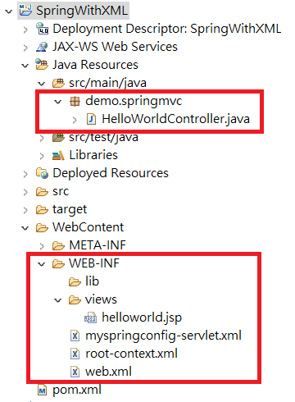
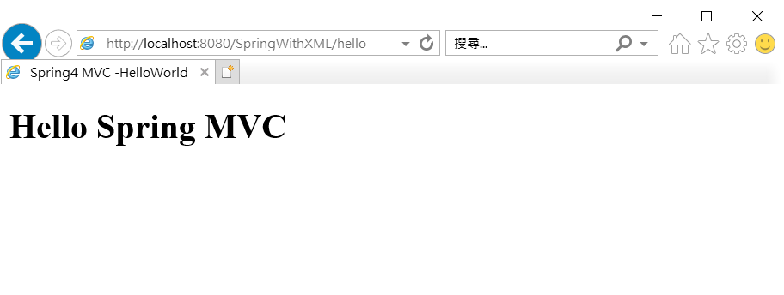
補充:
控制器中的重定向
使用字首 "redirect:" ，該方法返回字串，可以重定向到另一頁面。
RedirectExampleController.java
package demo.springmvc;

import org.springframework.stereotype.Controller;
import org.springframework.ui.Model;
import org.springframework.web.bind.annotation.RequestMapping;
import org.springframework.web.bind.annotation.RequestMethod;

@Controller
public class RedirectExampleController {

@RequestMapping(value = "/redirect", method = RequestMethod.GET)
public String authorInfo(Model model) {
return "redirect:/hello";
}
@RequestMapping("/hello")
public String hello(Model model) {
model.addAttribute("greeting", "Hello Spring MVC");
return"helloworld";
}
}

@RequestParam範例
使用@RequestParam 註解將請求引數系結到你的控制器方法引數。
下面的程式碼片段顯示了這個用法：
RequestParamExampleController.java

package demo.springmvc;
import org.springframework.stereotype.Controller;
import org.springframework.ui.Model;
import org.springframework.web.bind.annotation.RequestMapping;
import org.springframework.web.bind.annotation.RequestParam;

@Controller
public class RequestParamExampleController {

@RequestMapping("/user")
public String userInfo(Model model,
@RequestParam(value = "name", defaultValue = "Guest") String name) {

model.addAttribute("name", name);

if("admin".equals(name)) {
model.addAttribute("email", "admin@demo.com");
} else{
model.addAttribute("email", "Not set");
}
return "userInfo";
}

}
/WEB-INF/views/userInfo.jsp
<html>
<head>
<meta http-equiv="Content-Type" content="text/html; charset=utf-8">
<title>User Info</title>
</head>
<body>
<h2>${name}</h2>
Email: ${email}
<br>
</body>
</html>

@PathVariable範例
在Spring MVC中，可以使用@PathVariable註釋將一個方法引數系結到一個URI模板變數的值：
例如，這是一個樣板的URI：
/web/fe/{sitePrefix}/{language}/document/{id}/{naturalText}
而下面的 URI 模板匹配上面：
/web/fe/default/en/document/8080/spring-mvc-for-beginners
/web/fe/default/tw/document/8080/spring-mvc
.....

下面的程式碼片段顯示了用法：
PathVariableExampleController.java
package demo.springmvc;

import org.springframework.stereotype.Controller;
import org.springframework.ui.Model;
import org.springframework.web.bind.annotation.PathVariable;
import org.springframework.web.bind.annotation.RequestMapping;

@Controller
public class PathVariableExampleController {
/**
* @PathVariable Example:
*
*/ @RequestMapping("/web/fe/{sitePrefix}/{language}/document/{id}/{naturalText}")
public String documentView(Model model,
@PathVariable(value = "sitePrefix") String sitePrefix,
@PathVariable(value = "language") String language,
@PathVariable(value = "id") Long id,
@PathVariable(value = "naturalText") String naturalText) {

model.addAttribute("sitePrefix", sitePrefix);
model.addAttribute("language", language);
model.addAttribute("id", id);
model.addAttribute("naturalText", naturalText);

String documentName = "Java tutorial for Beginners";
if(id == 8080) {
documentName = "Spring MVC for Beginners";
}

model.addAttribute("documentName", documentName);

return "documentView";
}
}
/WEB-INF/views/documentView.jsp
<html>
<head>
<meta http-equiv="Content-Type" content="text/html; charset=utf-8">
<title>${documentName}</title>
</head>
<body>

<h3>${documentName}</h3>

Site Prefix: ${sitePrefix}
<br> Language: ${language}
<br> ID: ${id}
<br> Natural Text: ${naturalText}
<br>

</body>
</html>

@ResponseBody範例
如果您使用 @ResponseBody 注釋到方法， spring 將嘗試轉換它的返回值，並自動寫入到HTTP響應。在這種情況下，並不需要一個特定的檢視。
註：方法不一定需要返回字串型別。

使用@ResponseBody和方法返回字串的簡單例子。

ResponseBodyExample1Controller.java
package demo.springmvc;

import org.springframework.stereotype.Controller;
import org.springframework.ui.Model;
import org.springframework.web.bind.annotation.RequestMapping;
import org.springframework.web.bind.annotation.ResponseBody;

@Controller
public class ResponseBodyExample1Controller {

// Simple example, method returns String.
@RequestMapping(value = "/saveResult")
@ResponseBody
publicString authorInfo(Model model) {
return "saved";
}

}

